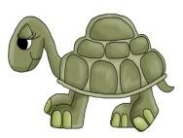

Des animaux ont visité ma tente de camping ! Trouve les endroits.

# A B C D E

|  |  |  |  |  |
| --- | --- | --- | --- | --- |
|  |  |  |  |  |
|  |  |  |  |  |
|  |  |  |  |  |
|  |  |  |  |  |
|  |  |  |  |  |

1

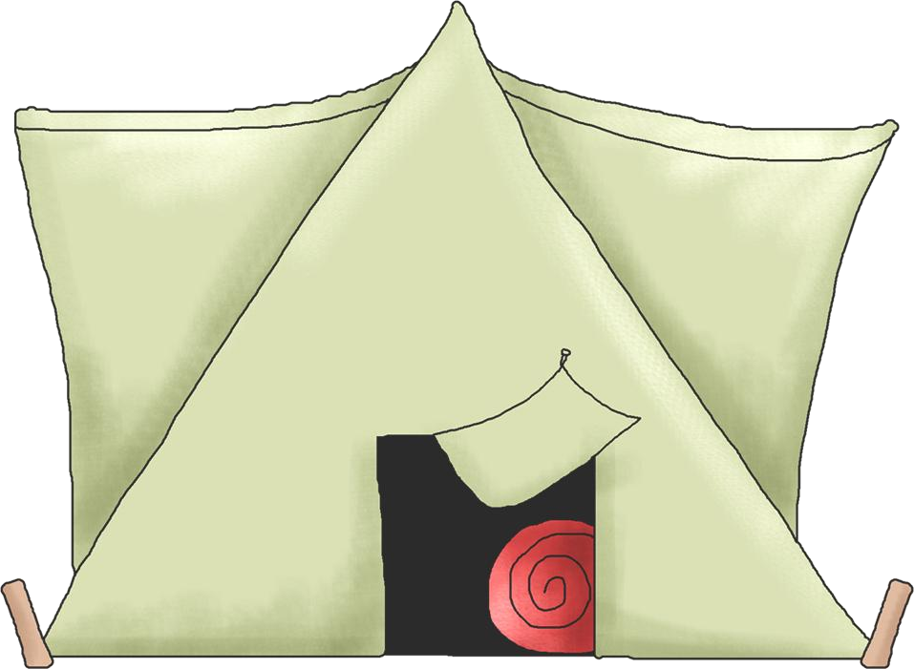

2

3

4

5

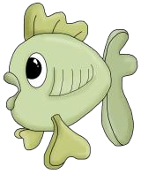67777777777777777777777777777777777

|  |  |  |  |  |
| --- | --- | --- | --- | --- |
| C 3 | A 3 | B 4 | D 2 | E 5 |
| B 5 | B 3 | E 2 | A 2 | E 4 |